1.98: Define 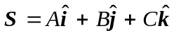

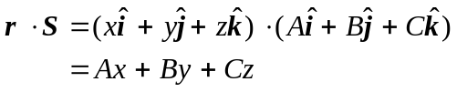

If the points satisfy Ax + By + Cz = 0, then 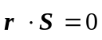 and all points are perpendicular to 

